Visualize ODE with Scipy
https://github.com/HiyawTaken/CST305/tree/main/Project%201

Hiyaw Ertiro, Ashton Calkins
CET, Grand Canyon University
CST-305: Principles of Modeling and Simulation
Professor Citro Ricardo
January 14, 2025

Responsibilities
Ashton Calkins - Worked on writing code as well as modeling computer system requirements and descriptions of such, focused on the mathematical approach
Hiyaw Ertiro - Also worked on code and worked on modeling system requirements and description of the computer system modeled, focused on the flow chart code approach

Context
This ODE models how a computer system’s performance changes as workload increases. It shows whether a server can keep up with incoming requests or becomes overloaded, helping predict queue buildup, response delays, and stability under sustained demand.

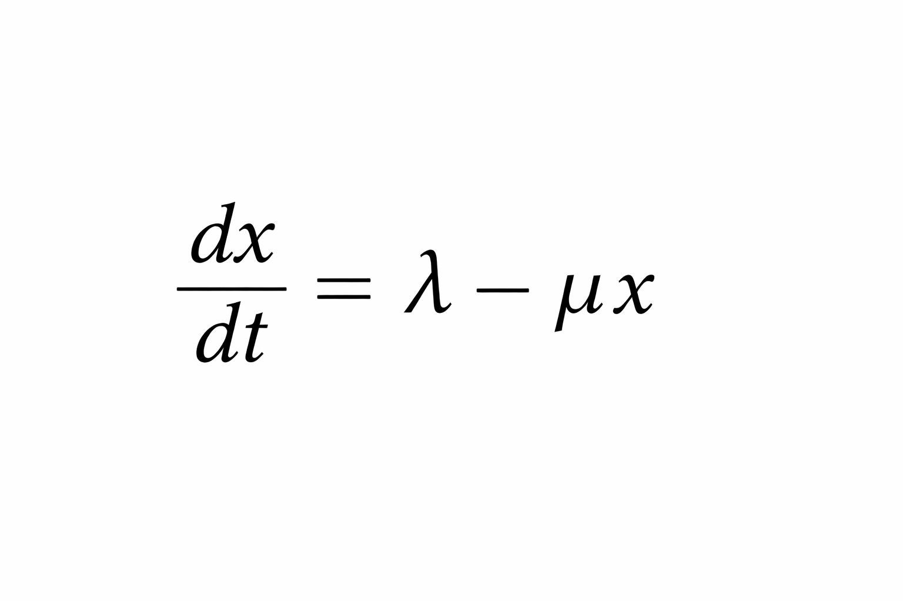
Specific Problem Solved
A web server receives incoming HTTP requests at an average rate of 6 requests per second. The server processes requests with an efficiency such that the processing rate is proportional to the current queue size, with it at a constant 0.8 s⁻¹. Initially, 25 requests are waiting in the queue.
We want to determine:
- How the queue size changes over time
- Whether the system is stable
- The long-term (steady-state) queue size
x(t) = number of queued requests at time ttt
λ= 6 requests/sec (arrival rate)
μ= 0.8 (service efficiency)

dt/dx ​= λ-μx= 6−0.8x
Initial condition:
x(0)=25

Mathematical Approach for Solving
This is a first-order linear ODE:

Step 1: Find steady state
Set dx/dt=0
6 − 0.8x = 0 ⇒ x* = 6/0.8 = 7.56
So the system stabilizes at 7.5 queued requests

Step 2: Full solution
The general solution is:
x(t) = x* + (x₀ − x*) e^{-ut}
Substitute values:
x(t) = 7.5 + (25 − 7.5) e^{-0.8t}
x(t) = 7.5 + (25 - 7.5)e^{-0.8t}

Interpretation (System Performance Meaning)

- The server starts overloaded (25 requests waiting)
- Processing capacity exceeds arrival rate
- The queue shrinks exponentially
- The system stabilizes at 7.5 requests

Approach for Implementation
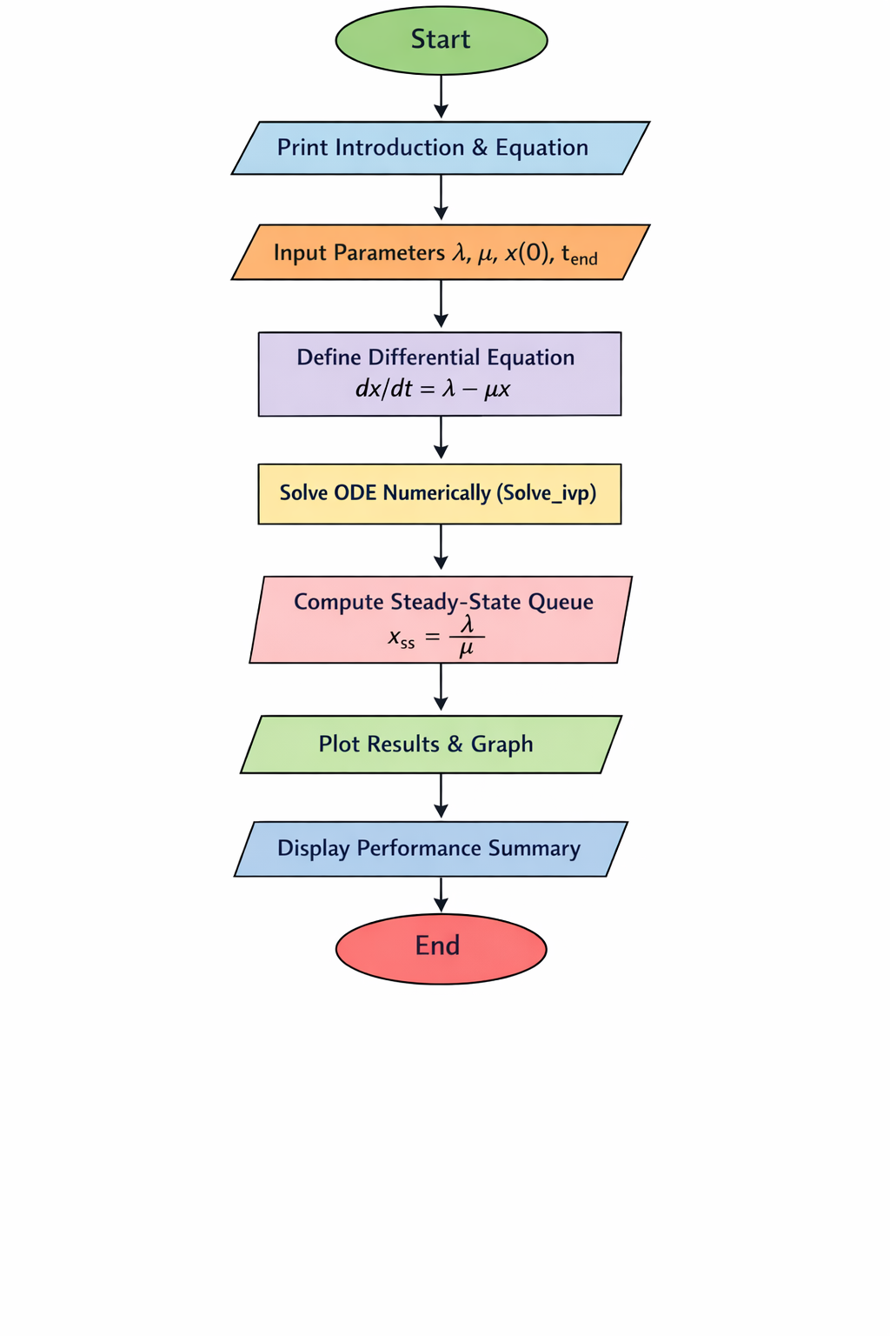

Screenshots of Key Phases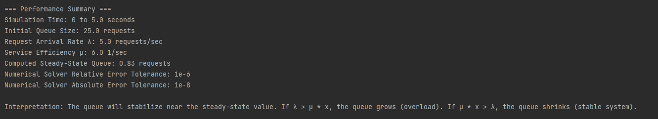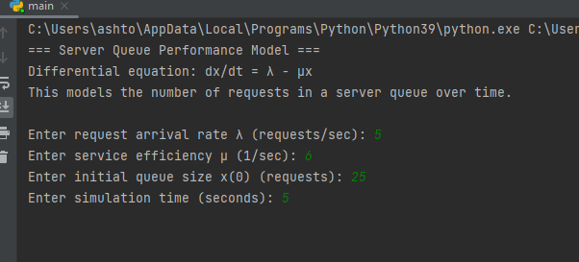

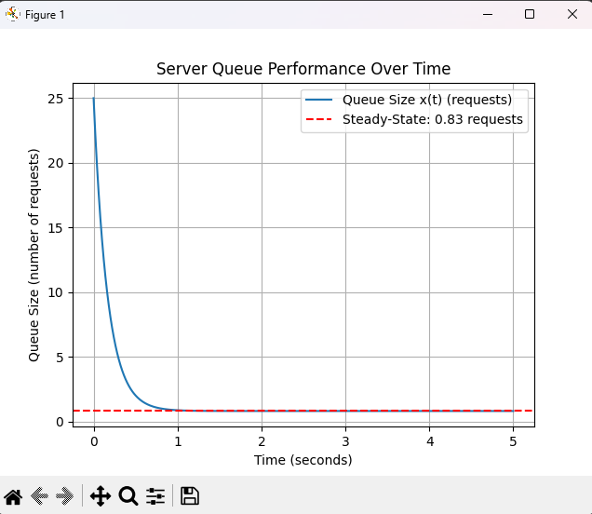
References
Boylestad, R. L., & Nashelsky, L. (2015). Queueing theory and system performance. Academic Press.
Used for the theoretical basis of queue models, steady-state behavior, and stability interpretation.
SciPy Developers. (2024). scipy.integrate.solve_ivp documentation.
https://docs.scipy.org/doc/scipy/reference/generated/scipy.integrate.solve_ivp.html
Used for numerical solution of ordinary differential equations in Python.
NumPy Developers. (2024). NumPy documentation.
https://numpy.org/doc/
Used for numerical arrays and time discretization.
Hunter, J. D. (2007). Matplotlib: A 2D graphics environment. Computing in Science & Engineering, 9(3), 90–95.
Used for visualization of ODE solutions.

